Plug-and-Stay Performance

[Watch Video](https://www.kingston.com/en/video/play?videoId=iygsxMj8lGJX1JBMQXiWCZqmPCbQ6Akctckh6hCgwS0DvjBOKeyp4Aiuy9QXR10YebGfU5RXW8gkpY4L-lyQOg2&start=0&autoPlay=False&chromeless=False&captionOption=No)

DTMC3G2

* [Intro](https://www.kingston.com/en/usb-flash-drives/datatraveler-micro#product-features)
* [Key Features](https://www.kingston.com/en/usb-flash-drives/datatraveler-micro#key-feature)
* [Specifications](https://www.kingston.com/en/usb-flash-drives/datatraveler-micro#specifications)
* [Resources](https://www.kingston.com/en/usb-flash-drives/datatraveler-micro#links)
* [Datasheet](https://www.kingston.com/datasheets/dtmc3g2_us.pdf)

[**Buy**](https://www.kingston.com/en/usb-flash-drives/datatraveler-micro#atc)

DataTraveler Micro USB Flash Drivewith Ultra-Small Premium Metal Design

DataTraveler® Micro is an ultra-small, lightweight USB drive ideal for convenient plug-and-stay storage that’s compatible with computers, printers, gaming consoles and more. The drive is designed with a low-profile, premium metal casing and built-in key loop to leave in USB ports without interference. DT Micro delivers USB 3.2 Gen 1 speeds up to 200MB/s read1 and up to 256GB2 capacities to quickly transfer and store large files such as movies, music, games and photos.

* Ultra-small, premium metal design
* Fast data transfer speeds up to 200MB/s1 read
* High capacity storage up to 256GB2

Key Features



Ultra-small, plug-and-stay design

Low-profile, premium metal casing designed to leave in a USB port with little interference

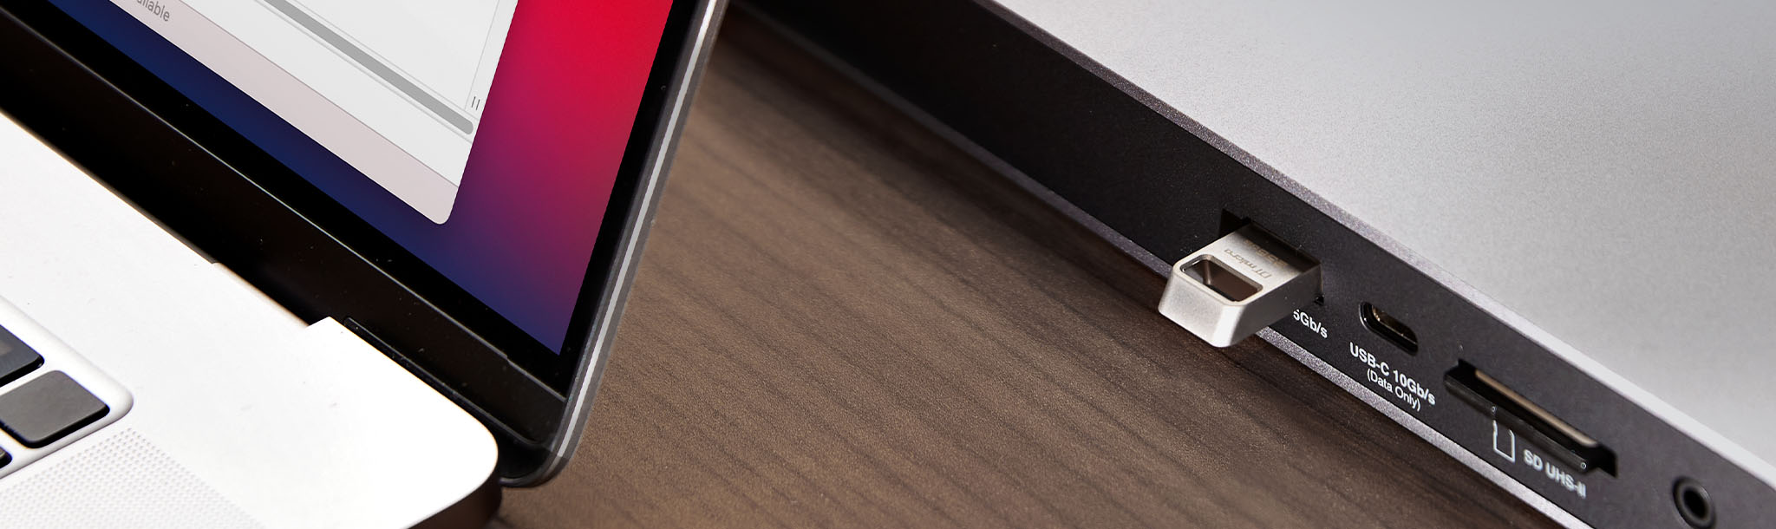

15x faster than standard USB 2.0 drives1

Store and transfer content quickly with high-performance USB 3.2 speeds up to 200MB/s1 read

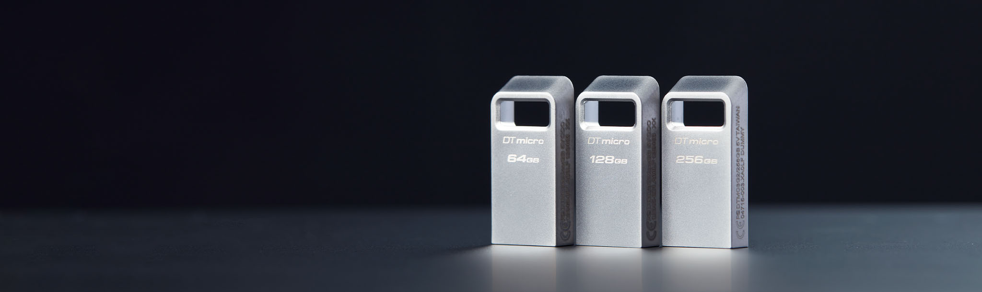

Expanded capacities

High capacity storage up to 256GB2

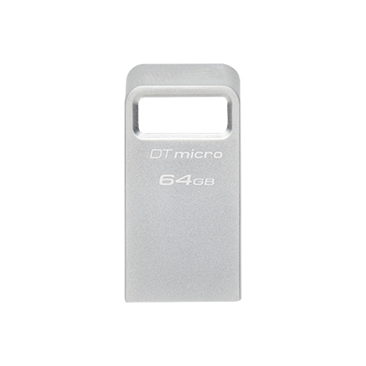

* [DataTraveler Exodia M 64GB](javascript:void(0))
* [DT Micro (DTMC3G2)](javascript:void(0))
* [DT Micro (DTMC3G2)](javascript:void(0))

Capacity

 64GB

 128GB

 256GB

* Part Number: DTMC3G2/64GB
* Ultra-small, capless design with metal casing
* USB 3.2 Gen 1
* 200MB/s Read

[**Where to Buy**](https://www.kingston.com/en/wheretobuy)

Specifications

|  |  |
| --- | --- |
| Capacities2 | 64GB, 128GB, 256GB |
| Speed1 | USB 3.2 Gen 1, 200MB/s Read |
| Dimensions | 24.95mm x 12.2mm x 4.5mm |
| Operating temperature | 0°C~60°C |
| Storage temperature | -20°C~85°C |
| Warranty/support | 5-year warranty, free technical support |
| Compatible with | Windows® 11, 10, 8.1, macOS® (v.10.14.x +), Linux (v. 2.6.x +), Chrome OS™ |

Related Articles

* [](https://www.kingston.com/en/blog/personal-storage/how-to-format-a-usb-flash-drive)
  + [Personal Storage](https://www.kingston.com/en/blog/personal-storage)

* + [Mobile Lifestyle](https://www.kingston.com/en/blog/mobile-lifestyle)

* + [USB Flash Drives](https://www.kingston.com/en/blog/topic/usb-flash-drives)

[How to Format a USB Flash Drive](https://www.kingston.com/en/blog/personal-storage/how-to-format-a-usb-flash-drive)

We explain how to format a USB flash drive in Windows and Mac OS 10+.

* [](https://www.kingston.com/en/blog/personal-storage/recycle-old-electronics)
  + [Personal Storage](https://www.kingston.com/en/blog/personal-storage)

[Don’t Let Old Tech Go to Waste: Recycle Your Old Devices](https://www.kingston.com/en/blog/personal-storage/recycle-old-electronics)

Electronics donation and recycling is a great way to help conserve resources and natural materials.

* [](https://www.kingston.com/en/blog/personal-storage/using-usb-drive-on-mac)
  + [USB Flash Drives](https://www.kingston.com/en/blog/topic/usb-flash-drives)

* + [Personal Storage](https://www.kingston.com/en/blog/personal-storage)

[Using a USB Drive on a Mac](https://www.kingston.com/en/blog/personal-storage/using-usb-drive-on-mac)

We will go over how to use a USB drive, thumb drive, flash drive, pendrive, etc, on a Mac computer.

* [](https://www.kingston.com/en/blog/mobile-lifestyle/usb-c-explained)
  + [Mobile Lifestyle](https://www.kingston.com/en/blog/mobile-lifestyle)

* + [Personal Storage](https://www.kingston.com/en/blog/personal-storage)

* + [USB Flash Drives](https://www.kingston.com/en/blog/topic/usb-flash-drives)

* + [USB-C](https://www.kingston.com/en/blog/topic/usb--c)

[USB-C Explained](https://www.kingston.com/en/blog/mobile-lifestyle/usb-c-explained)

USB-C is a small, slim connector. Its symmetrical and reversible shape is what makes it popular.

* [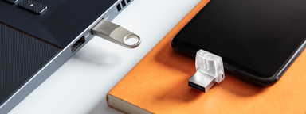](https://www.kingston.com/en/usb-flash-drives/usb-30)
  + [USB Flash Drives](https://www.kingston.com/en/blog/topic/usb-flash-drives)

* + [Mobile Lifestyle](https://www.kingston.com/en/blog/mobile-lifestyle)

* + [Personal Storage](https://www.kingston.com/en/blog/personal-storage)

* + [USB-C](https://www.kingston.com/en/blog/topic/usb--c)

* + [Android](https://www.kingston.com/en/blog/topic/android)

* + [Reader](https://www.kingston.com/en/blog/topic/reader)

[What’s the Difference Between USB 3.1 Gen 1, Gen 2 and USB 3.2?](https://www.kingston.com/en/usb-flash-drives/usb-30)

USB 3.1 Gen 1 supports speeds of up to 5Gbit/s while USB 3.1 Gen 2 supports speeds of up to 10Gbit/s.

* [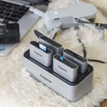](https://www.kingston.com/en/blog/personal-storage/workflow-station-card-reader-easy-content-creators-video-pros)
  + [Personal Storage](https://www.kingston.com/en/blog/personal-storage)

* + [PC Performance](https://www.kingston.com/en/blog/pc-performance)

* + [Memory Cards](https://www.kingston.com/en/blog/topic/memory-cards)

* + [Reader](https://www.kingston.com/en/blog/topic/reader)

* + [USB Flash Drives](https://www.kingston.com/en/blog/topic/usb-flash-drives)

* + [Photography and videography](https://www.kingston.com/en/blog/topic/photography-and-videography)

[The Kingston Workflow Station Makes Things Easy for Content Creators and Video Professionals](https://www.kingston.com/en/blog/personal-storage/workflow-station-card-reader-easy-content-creators-video-pros)

Learn how the Kingston Workflow Station can make file transfers out in the field faster for professionals.

* [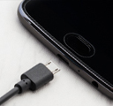](https://www.kingston.com/en/usb-flash-drives/otg)
  + [USB Flash Drives](https://www.kingston.com/en/blog/topic/usb-flash-drives)

* + [Mobile Lifestyle](https://www.kingston.com/en/blog/mobile-lifestyle)

* + [Personal Storage](https://www.kingston.com/en/blog/personal-storage)

[USB OTG Flash Drives - DataTraveler MicroDuo](https://www.kingston.com/en/usb-flash-drives/otg)

OTG drives function just like a standard Flash drive and are easier and more convenient than using cloud services.

* [](https://www.kingston.com/en/blog/pc-performance/tips-to-speed-up-windows-10)
  + [Personal Storage](https://www.kingston.com/en/blog/personal-storage)

* + [PC Performance](https://www.kingston.com/en/blog/pc-performance)

* + [SSD](https://www.kingston.com/en/blog/topic/ssd)

* + [Memory](https://www.kingston.com/en/blog/topic/memory)

[10 Ways to Speed Up a PC Running Windows 10](https://www.kingston.com/en/blog/pc-performance/tips-to-speed-up-windows-10)

If you’re finding your PC performance slowing down these tips can help improve your speeds and PC efficiency.

Resources

* [**Warranty**](https://www.kingston.com/en/company/warranty)
* [**Storage Chart**](https://www.kingston.com/en/memory-cards/storage-chart)
* [**Caring for your Flash Memory**](https://www.kingston.com/en/usb-flash-drives/caring-for-your-flash-memory)
* [**Flash Memory Guide**](https://www.kingston.com/en/flashguide)
* [**DataTraveler Comparison**](https://www.kingston.com/en/usb-flash-drives/datatraveler-comparison-chart)
* [**What is USB 3.1?**](https://www.kingston.com/en/usb-flash-drives/usb-30)